Assignment 5
Relational and Logical Operators.
- Write a query that will give you all orders for more than Rs. 1,000.
Query:
mysql> select * from orders
-> where amt>1000;
Output:
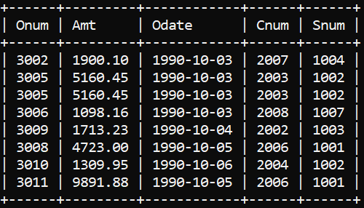

- Write a query that will give you the names and cities of all salespeople in London with a commission above .10.
Query:
mysql> select sname, city from salespeople
-> where city = 'London' and Comm > 0.10;
Output:

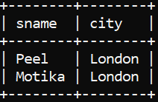

- Write a query on the Customers table whose output will exclude all customers with a rating <= 100, unless they are located in Rome.
Query:
mysql> select * from customers
-> where rating <= 100 or city = 'Rome';
Output:

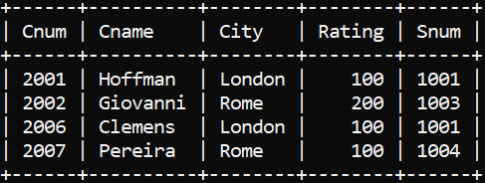

- What will be the output from the following query?
Select * from Orders
where (amt < 1000 OR
NOT (odate = ‘1990-10-03’
AND cnum > 2003));
Output:
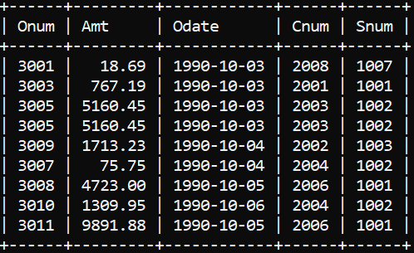
- What will be the output of the following query?
Select * from Orders
where NOT ((odate = ‘1990-10-03’
OR snum >1006) AND amt >= 1500

Output:
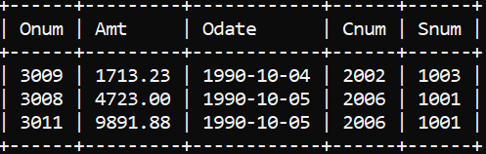

- What is a simpler way to write this query?
Select snum, sname, city, comm From Salespeople
where (comm > .12 OR comm <.14);

Query:
mysql> select * from salespeople
-> where comm between 0.12 and 0.14;

Output:
